This is a team assignment.

Purpose: To introduce the student to DC motors by exploring PWM and RPM values.

Grade: 25 Points
Lab Report: 5 points
Source Code: 15 points
Video: 5 points

Procedure: Use and modify given motor and encoder codes, find a correlation between PWM values vs RPMs and plot RPM (as Y - vertical) vs PWM (as X - horizontal).
You can do it in the code automatically (by changing PWM values one at a time from 0 with an increment of 5 till 255 and record the RPM values)
Once you have the data, plot it with EXCEL.
Repeat for 2 cases:
a. No load – the wheels are free-spinning (lift the robot or put it on a block of wood)
b. Regular load – the wheels are carrying the robot moving (you must carry the laptop tethered with moving robot to record the values)
Note: You will be generating data, and you will need to extract the values returned from the motor. You can either use your Bluetooth module to send the data back to your phone/terminal emulator, or you can use the serial output debugging window to capture these values – but then will need to have your laptop tethered to the car as it is moving. You decide!

Submit both your code and the plots in an EXCEL file.
Question 1: What is the difference between PWM values and RPM values? What does this tell you?
The PWM values represent the analog signal being sent to the motors which are then converted into a percentage of motor speed. The RPM value is what actual speed that analog value is interpreted as.
Question 2: What is the distance traveled by one rotation of the wheel?
The circumference of the wheels is 223.84 mm
Question 3: Using your Interrupt Service Routine, what is the count for one full rotation of the wheel?
When one rotation is accomplished the count is 180.

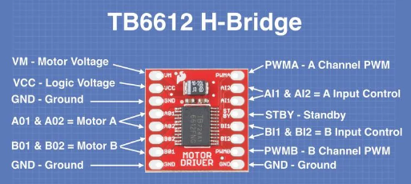
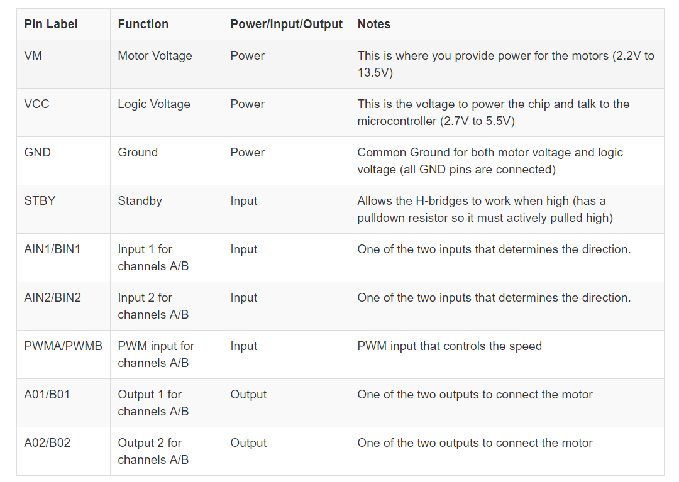

RPM vs PMW for case a: Free-spinning wheels

